Supporting Information
Rec. Nat. Prod. X:X (202X) XX-XX
Phytochemical Constituents, Antibacterial, Synergistic Antibacterial, Cytotoxic, and Antioxidant Activities of the Essential Oil of Rhizomes of Davallia bullata Wall. ex Hook.

Fan Xu ¹, Xiran Chen ¹, Jinyi Zhang ¹, Chunlei Qu ¹, Ling Gu ² and Xiang Xing ^{2∗}
¹ Sdu-Anu Joint Science College, Shandong University, Weihai, 264209, China
² Marine College, Shandong University, Weihai 264209, China

Table of Contents | Page
Figure S1: GC/MS Chromatogram of the essential oil of D. bullata | 1
Table S1: Unknown chemical composition of the essential oil of D. bullata | 2
Figure S2: MS spectrum of Unknown 1 | 2
Figure S3: MS spectrum of Unknown 2 | 2
Figure S4: MS spectrum of Unknown 3 | 2
Figure S5: MS spectrum of Unknown 4  Figure S6: MS spectrum of Unknown 5 | 3  3

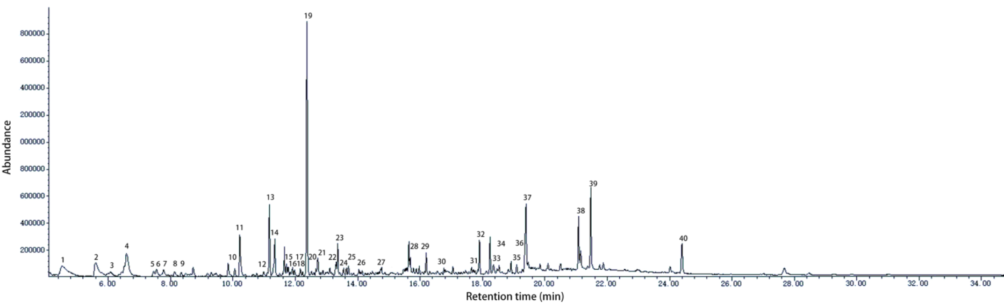
Figure S1: GC/MS Chromatogram of the essential oil of D. bullata

Table S1. Unknown chemical composition of the essential oil of D. bullata
No | RT (min) | RI | GC-MS spectrum
Unknown 1 | 8.731 | 1226 | Figure S2
Unknown 2 | 9.853 | 1292 | Figure S3
Unknown 3 | 11.652 | 1401 | Figure S4
Unknown 4 | 15.641 | 1670 | Figure S5
Unknown 5 | 18.241 | 1866 | Figure S6

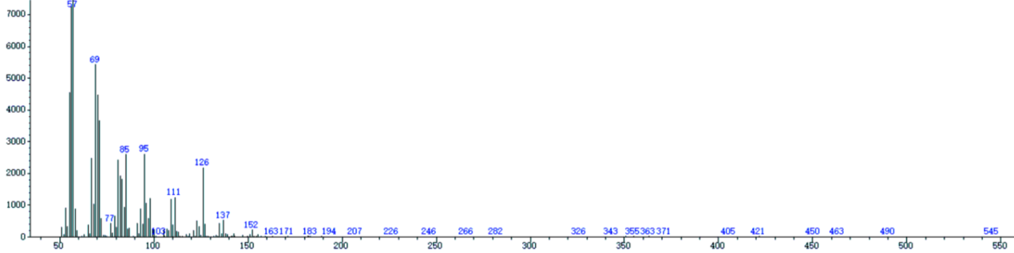
Figure S2: MS spectrum of Unknown 1

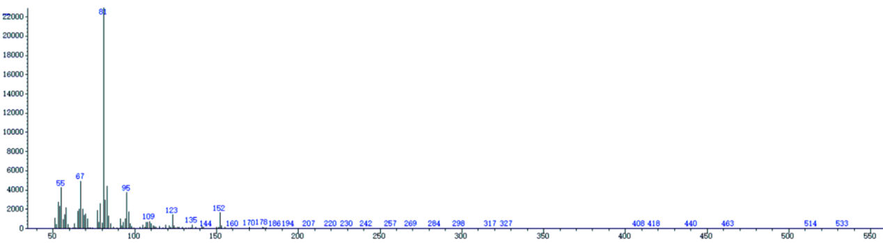
Figure S3: MS spectrum of Unknown 2

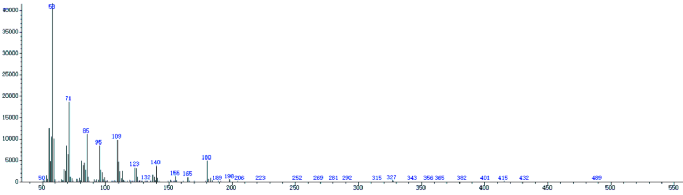
Figure S4: MS spectrum of Unknown 3

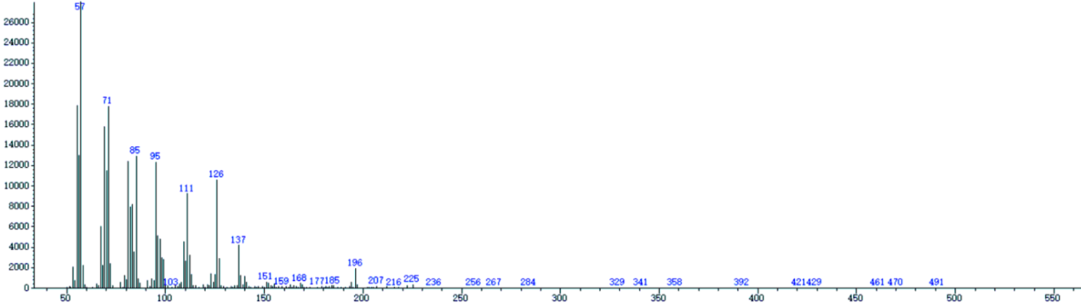
Figure S5: MS spectrum of Unknown 4

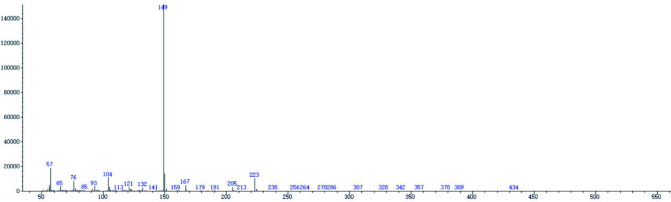
Figure S6: MS spectrum of Unknown 5

